**Laboratory 15**: Our first Intro to Matlab

(Edit this document as needed)

Partner 1: John Gonzalez

Partner 2: Saaif Ahmed

*Part A*

Brief description of the basic math Matlab experiment:

Understand how Matlab works as a calculator for simple operations commonly found in circuit analysis and how Matlab deals with irrational/non-real numbers.

|  |  |  |
| --- | --- | --- |
| Operation | Example | Answer |
| Sum | 333+614+218 | 1165 |
| Difference | 333-292 | 41 |
| Multiplication | 333×292 | 97236 |
| Division | 333/29 | 11.4828 |
| Raising to a Power | 553 | 166375 |
| Roots | sqrt(419) in Matlab | 20.4695 |
| Round | round(456.79) | 457 |
| Defining a Variable | y = 67 | y = 67 |
| Operating on a variable | sqrt(y) in Matlab | 8.1854 |
| What is π?1 | π | 3.14156 |
| Sines & Cosines | sin(pi/3) | .8660 |
| ln Functation (natural logarithm) | ln(4)  log(4) in Matlab | 1.3863 |
| Natural Number *e* | *e* | 2.7183 |
| Inverse Tangent2 | tan-1(1)  atan(1) in Matlab | .7854 |
|  |  |  |
|  |  |  |

1In Matlab, π is entered as ‘pi’ (no quotes)

2In Matlab, try atan(-1), why is the angle wrong, type ‘help atan2’ (no quotes)

*Part B*

Brief description of the Matlab demos experiment:

Get started with running programs within Matlab and observe the multitude of functionalities when running programs.

Which demos did you try? (Many of them are really interesting.) Copy some of the results here.

Penny Demo

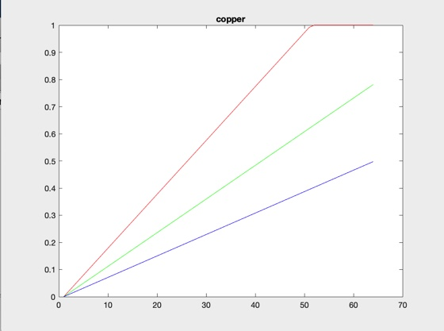

*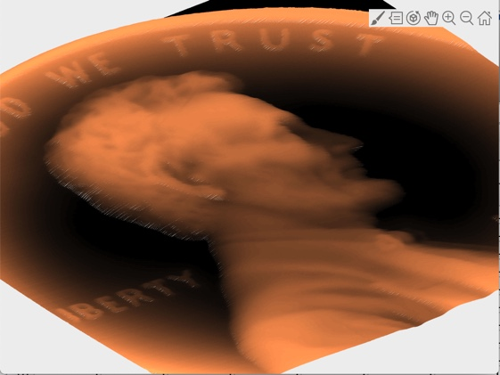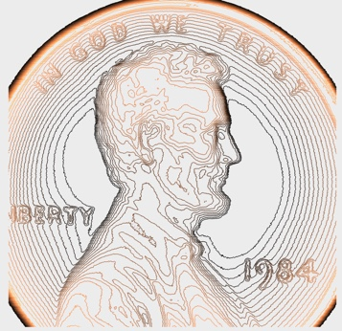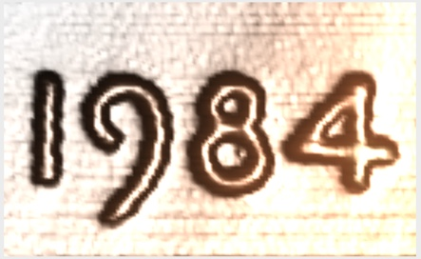Part C*

Brief description of the array math Matlab experiment:

Understand the math operations within Matlab and review the matrix operations necessary for future experiments.

|  |  |
| --- | --- |
| Operation | Answer |
| sum(R) | 55 |
| mean(R) | 5 |
| median(R) | 5 |
| min(R) | 0 |
| max(R) | 10 |
| S = 5R  S = 5*R in Matlab | [0 5 10 15 20 25 30 35 40 45 50] |
| V = R+S | [0 6 12 18 24 30 36 42 48 54 60] |
| T = R2  T = R .^2 in Matlab* | [0 1 4 9 16 25 36 49 64 81 100] |

\***Important note**, the dot in the ‘.^’ syntax is needed to do what is called array math. Array math is element by element math, where each element in array is multiplied by the equivalent element in another array. If you forget the dot, Matlab attempts to do Matrix math, which gives you a different answer (or an error).

What is the output of the following matrix assignment command? (copy and paste is fine)

>> U = [0 1 2; 3 4 5; 6 7 8]

U =

0 1 2

3 4 5

6 7 8

What is the output of the following array assignment command? (copy and paste is fine)

>> t = [0:0.1:1]

t =

Columns 1 through 5

0 0.1000 0.2000 0.3000 0.4000

Columns 6 through 10

0.5000 0.6000 0.7000 0.8000 0.9000

Column 11

1.0000

What is the 22nd element of the following array assignment command?

>> t = 1e-3*[0:0.001:3];

2.1000e-05

*Part D*

(Saving plots, in the figure window, you can use the ‘Save as’ option to save your various plots as image files. Jpeg is a common format. You can then import them directly into Word using the Picture option under the Insert tab. Alternatively, you can use screenshots, though this tends to be much more wasteful with plotter ink.

Brief description of the Matlab plotting experiment:

Get used to the plot() functionality within Matlab and understand how the matrix plotting application works within the software, and how to edit the plots.

Basic plot of function 10sin(ωt+θ). The syntax for this function is

>> V = 10*sin(w*t+Th)

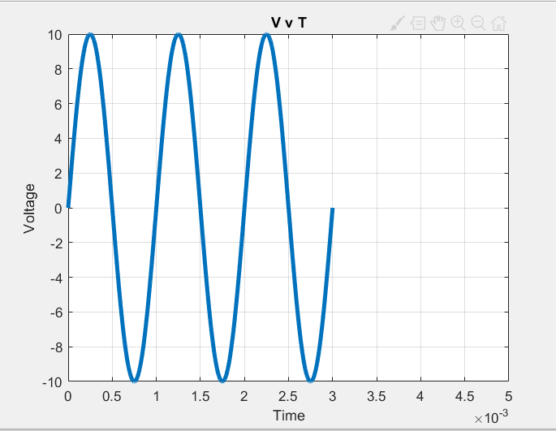

Plot of function 10cos(ωt+θ) with additional features.

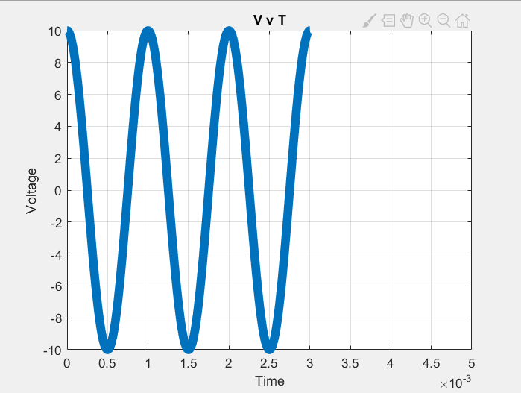

Plot of function 10e-t/τ. The syntax for this expression is

>> 10*exp(-t/tau)

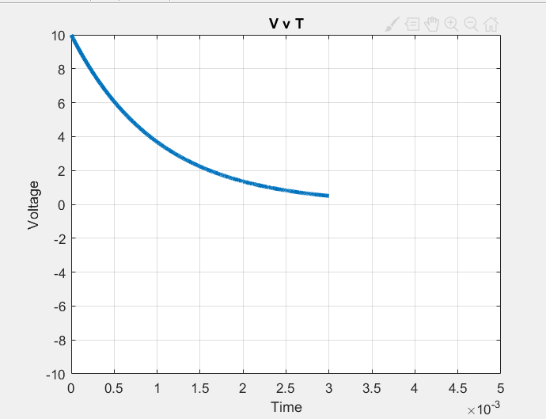

Plot of function 10e-t/τcos(ωt+θ). The syntax for this expression is

>> 10*exp(-t/tau).*cos(w*t+Th)

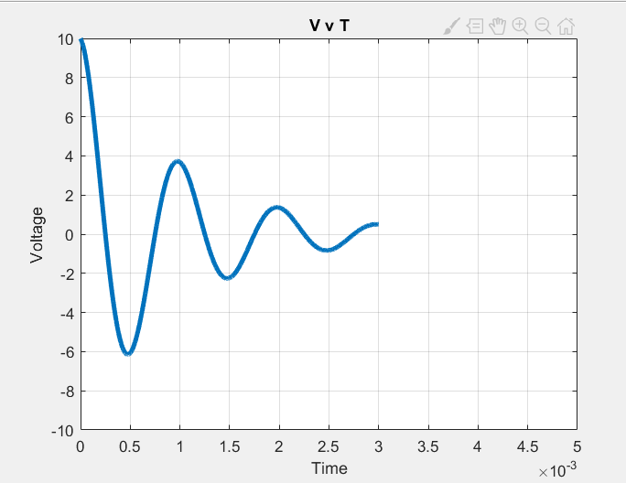

**Important note**, the dot in the ‘.*’ syntax is needed to do what is called array math. Array math is element by element math, where each element in array is multiplied by the equivalent element in another array. If you forget the dot, Matlab attempts to do Matrix math, which gives you a different answer (or an error).

Plots of two functions, Vocos(ωt+θV) and Iocos(ωt+θI), on the same plot. Select values for the phase angles as indicated in the experiment. There are several ways of plotting multiple plots on the same figure. One easy way is to plot the first figure, type “hold on” (no quotes), in the command prompt and then add the second plot.

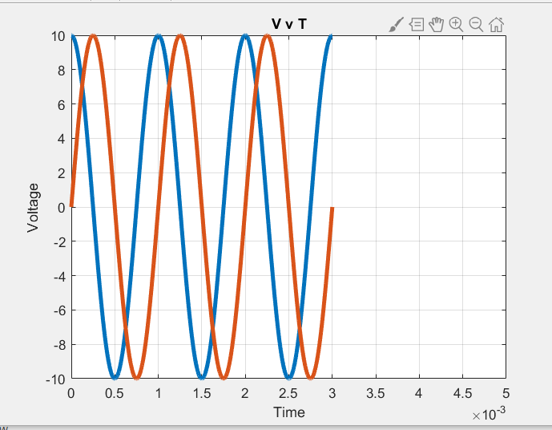 =-pi/2 =pi/2

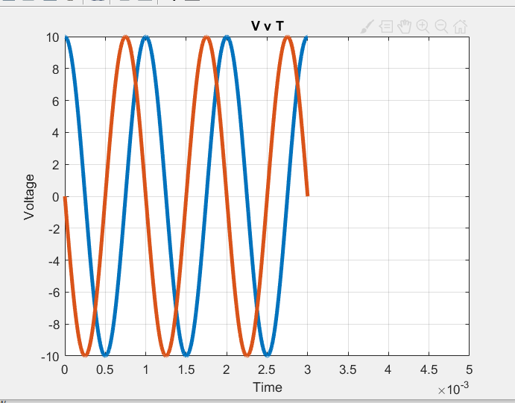

Plot of a function of interest to you.

=2t

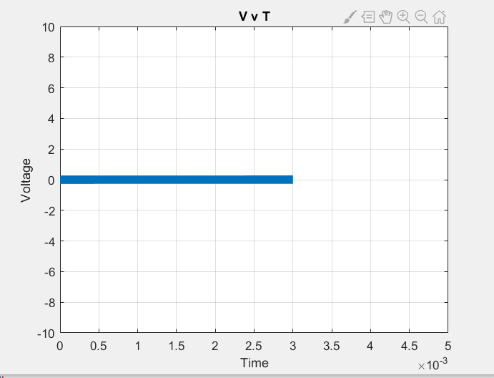

*Part E*

Brief description of the Matlab scripts experiment:

Run a script in Matlab and edit the script and functions within it to display our desired data.

What information is provided in the various windows provided when you open Matlab?

Command Window, Current Folder, Workspace, Command Line, Operation

Plots from the provided Matlab script. Note, you can copy and paste the script into your opened m-file.

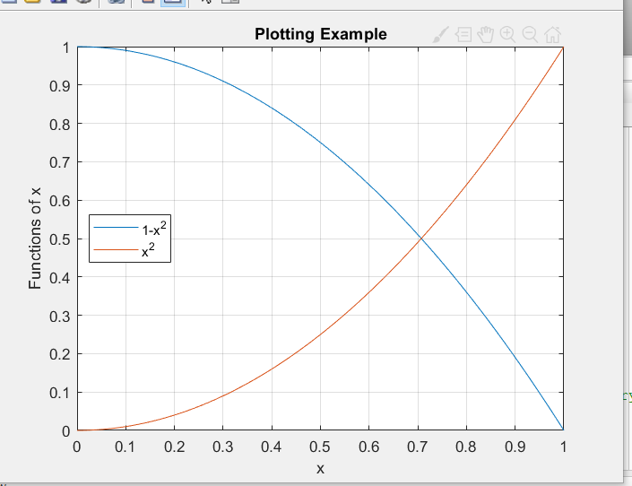

Plots from the updated script with the x3 function added.

